Microsoft DOS Commands
- date
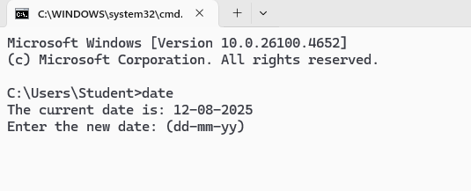

- time
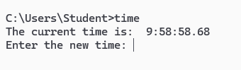

- prompt $p$q
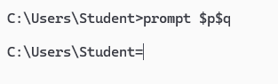

- color
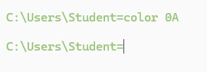

- ipconfig
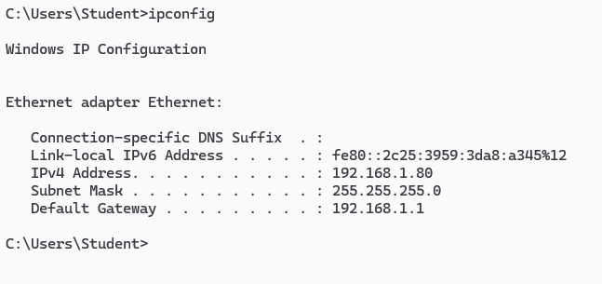

- ping
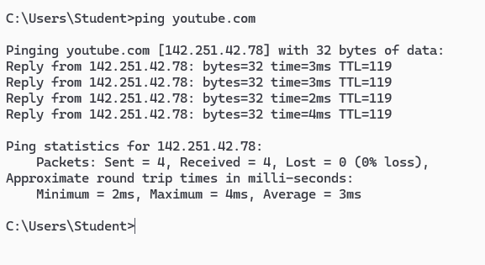

- doskey /history
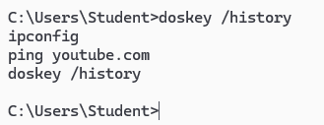
- echo
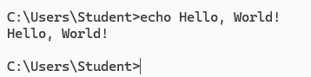

- mkdir/md FYIT_4
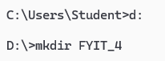

- cd FYIT_4
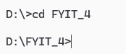

- copy file1.txt backup.txt
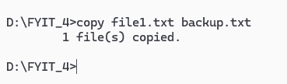

- move backup.txt "D:\FYIT_4\Backup"
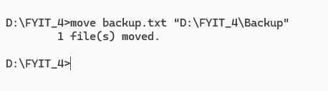
- del test.txt


- cls
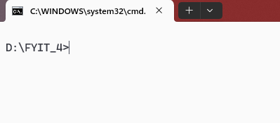

- type file1.txt
